Database Design Challenge
No. | Topic | Expected Main Entities
1 | 🏫 University Academic Management System | Student, Faculty, Course, Department, Enrollment, Exam
2 | 🏥 Hospital Management System | Patient, Doctor, Appointment, Treatment, Prescription, Bill
3 | 📚 Library Management System | Book, Member, Author, Publisher, Issue, Return
4 | 🛒 E-Commerce Order Management | Customer, Product, Order, Payment, Delivery, Review
5 | 🏦 Bank Account Management System | Customer, Account, Branch, Transaction, Loan
6 | 🍽️ Restaurant Management System | Customer, Menu, Order, Staff, Table, Payment
7 | 🏨 Hotel Reservation System | Guest, Room, Booking, Payment, Staff, Service
8 | 🚗 Vehicle Rental System | Customer, Vehicle, Rental, Payment, Branch, Maintenance
9 | 🎓 Student Placement Management System | Student, Company, Job, Application, Interview, Offer
10 | 🚌 College Transportation Management | Student, Bus, Driver, Route, Stop, Allocation
11 | 💊 Pharmacy Management System | Medicine, Supplier, Customer, Purchase, Sale, Prescription
12 | 🎬 Movie Ticket Booking System | Movie, Theatre, Screen, Show, Customer, Ticket
13 | ✈️ Airline Reservation System | Passenger, Flight, Airport, Ticket, Payment, Seat
14 | 🏋️ Gym Management System | Member, Trainer, Membership, Payment, Workout
15 | 📦 Inventory Management System | Product, Supplier, Warehouse, Purchase, Stock, Sale
16 | 📱 Mobile Service Center System | Customer, Device, Technician, Service, SparePart, Bill
17 | 🏢 Employee Leave & Payroll System | Employee, Department, Attendance, Leave, Salary
18 | 🚦 Smart Traffic Management System | Vehicle, Road, Junction, Sensor, TrafficEvent
19 | 🏠 Apartment Management System | Resident, Flat, Owner, Maintenance, Payment, Visitor
20 | ⚽ Sports Tournament Management System | Team, Player, Match, Venue, Referee, Score

Recommended Assessment Pattern
Component | Marks
Identify minimum 6 entities | 1
Identify attributes | 1
Define Primary & Foreign Keys | 1
Draw ER Diagram | 1
Convert ER model to Relational Schema | 1
Total | 5 Marks

Example
University Academic Management System –
Suppose we are designing a database for a university to manage students, faculty, courses, departments, enrollments, and examinations.
1. Entities and Attributes
Entity | Attributes | Primary Key
STUDENT | Student_ID, Student_Name, DOB, Gender, Email, Phone, Dept_ID | Student_ID
FACULTY | Faculty_ID, Faculty_Name, Email, Phone, Dept_ID | Faculty_ID
DEPARTMENT | Dept_ID, Dept_Name, HOD | Dept_ID
COURSE | Course_ID, Course_Name, Credits, Dept_ID, Faculty_ID | Course_ID
ENROLLMENT | Enrollment_ID, Student_ID, Course_ID, Semester, Enrollment_Date | Enrollment_ID
EXAM | Exam_ID, Course_ID, Exam_Type, Exam_Date, Max_Marks | Exam_ID
2. Relationships
Relationship | Cardinality | Example
Department → Student | 1 : M | One department has many students
Department → Faculty | 1 : M | One department has many faculty members
Department → Course | 1 : M | One department offers many courses
Faculty → Course | 1 : M | One faculty teaches multiple courses
Student → Enrollment | 1 : M | One student can have many enrollments
Course → Enrollment | 1 : M | One course can have many students
Course → Exam | 1 : M | One course can have multiple exams
4. Simple ER Structure

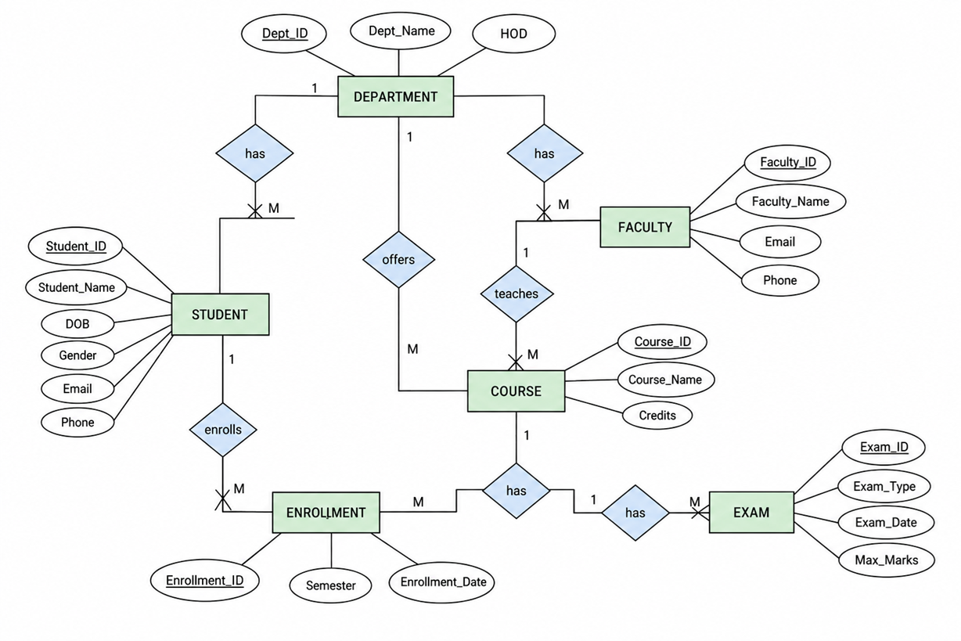
5. Relational Schema
DEPARTMENT(Dept_ID, Dept_Name, HOD)

STUDENT(Student_ID, Student_Name, DOB, Gender,
Email, Phone, Dept_ID)

FACULTY(Faculty_ID, Faculty_Name, Email,
Phone, Dept_ID)

COURSE(Course_ID, Course_Name, Credits,
Dept_ID, Faculty_ID)

ENROLLMENT(Enrollment_ID, Student_ID,
Course_ID, Semester, Enrollment_Date)

EXAM(Exam_ID, Course_ID, Exam_Type,
Exam_Date, Max_Marks)

